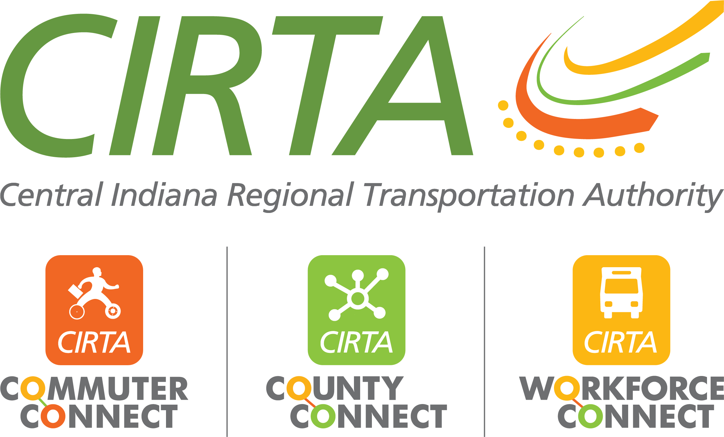
320 N. Meridian St., Suite 920
Indianapolis, IN 46204
317-327-7433
www.cirta.us

2024 CIRTA Board Meeting Dates
9am – 11:00am

February 13, 2024 – CIRTA Office
April 16, 2024 – IndyGo East Campus
June 11, 2024 – Community Health Pavilion Saxony (Fishers)
August 13, 2024– Community Health Pavilion Washington (East)
October 15, 2024– Community Health Pavilion Speedway
December 10, 2024– American Structurepoint

