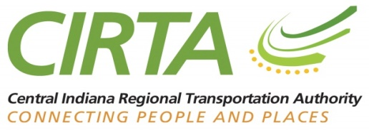

**Notice of Public Meeting**

Central Indiana Regional Transportation Authority (CIRTA) Board

June 13th, 2023, at 9 a.m.

City of Shelbyville Conference Center

2154 Intelliplex Drive

Shelbyville, IN 46176

**AGENDA**

1. Introductions
2. Consent Agenda Items:
   1. Consideration of Memorandum of Regular Board Meeting of April 11th, 2023
   2. Accounts Payable Voucher Register
   3. Financial Report
   4. Grants Docket
   5. Mobility Management Updates
   6. *Resolution #2023-06-13-01 – Adoption of Consent Agenda*
3. New Business
   1. *Resolution #2023-06-13-02 – Resolution to Approve American Structurepoint Invoice*
   2. *Resolution 2023-06-013-03 Resolution to Extend American Structurepoint Contract for Mobility Management Staff Support*
   3. *Resolution 2023-06-12-04 Resolution to Appoint Proxy Member to the IMPO Policy Board*
4. Presentation: TransPro Consulting- Workforce Connector Study
5. CIRTA Updates
   1. Legislative Update – R. Cockrum
   2. Commuter Connect – A. Meyer
   3. Mobility Management Update - D. Krieg
   4. Executive Update - J. Gebhard
6. Adjournment

The Next Regularly Scheduled Meeting:

**August 15th, 2023, American Structurepoint**

**9025 River Rd Ste. 200, Indianapolis, IN 46240**

Guests are reminded that the CIRTA Board meets in public, but it is not a public hearing. Questions or comments from the public can be submitted in writing to [info@cirta.us](mailto:info@cirta.us). Questions or comments may be made at meetings upon recognition by the Chair. Please reserve comments for the appropriate time.

In the event of inclement weather, CIRTA meetings follow the determination of the Indianapolis Public School Corporation. If IPS is cancelled, the meeting is postponed to a new date. If IPS is delayed, the meeting occurs at its originally scheduled time.

Agenda is subject to change without notice prior to the meeting.

Questions regarding this agenda may be directed to Jen Gebhard [jgebhard@cirta.us](mailto:jgebhard@cirta.us)