Central Indiana Regional Transportation Authority
Title VI Program and Complaint Procedure
- CIRTA Policy of Nondiscrimination
The Central Indiana Regional Transportation Authority (CIRTA) operates programs without regard to race, color and national origin as provided by Title VI of the Civil Rights Act of 1964. No person shall be denied the benefits of CIRTA programs based on his or her race, color, or national origin.
CIRTA is committed to practicing nondiscrimination. Persons believing, they have been subjected to discrimination based on race, color or national origin may file a complaint with CIRTA. CIRTA will publicize the nondiscrimination policy and complaint procedures on its website (http://www.cirta.us).
- CIRTA title VI Coordinator contact information
David Krieg
CIRTA Mobility Manager
320 N. Meridian St., Suite 920
Indianapolis IN 46204
317-327-7433
dkrieg@cirta.us
- CIRTA title VI Complaint Procedures

- Any individual, group of individuals, or entity that believes they have been subjected to discrimination prohibited by nondiscrimination requirements may file a complaint against CIRTA. A formal complaint must be filed within 180 calendar days of the alleged occurrence.
- Written, signed complaints should be submitted to: Mobility Manager, CIRTA, 320 N. Meridian St. Suite 920, Indianapolis, IN 46204. If the complainant is unable to provide a written complaint, a CIRTA staff member will assist the complainant in transcribing a verbal complaint into writing. The complaint must be signed by the complainant or his/her representative. Complaints must include dates of occurrences of discrimination and names and job titles of individuals involved when possible.
- Upon receiving the written complaint, CIRTA will determine its jurisdiction, acceptability, need for additional information, and the investigative merit of the complaint.
- Once CIRTA decides its course of action, the complainant and the respondent will be notified in writing of such determination within five calendar days. The complaint will be logged into the CIRTA data base/log by the Mobility Manager, and the basis for the allegation identified including race, color, national origin, disability, age, or sex.
- In cases where CIRTA assumes investigation of the complaint, CIRTA will provide the respondent with the opportunity to respond to the allegations in writing. The respondent will have ten calendar days upon receipt, to furnish CIRTA with his/her response to the allegations.
- Within 60 days of receipt of the complaint, the Mobility Manager will prepare a written investigative report. The report shall include a narrative description of the incident, identification of persons interviewed, findings and recommendations for disposition.
- The recommendation shall be reviewed with CIRTA’s attorney. The attorney may discuss the report and recommendations with the Executive Director and other appropriate CIRTA staff. The report will be modified as needed and made final for its release to the parties.
- Once the investigative report becomes final, briefings will be scheduled with each party within 15 calendar days. Both the complainant and the respondent shall receive a copy of the investigative report during the briefings and will be notified of their respective appeal rights.
- If the complainant or respondent is not satisfied with the results of the investigation of the alleged discriminatory practice(s), he or she shall be advised of their rights to appeal CIRTA’s decision to the Federal Transit Administration, U.S. Department of Transportation or U.S. Department of Justice. The complainant has 180 calendar days after CIRTA’s final resolution to appeal to USDOT. Appeals should be addressed to the Federal Transit Administration Region 5 Office, 200 West Adams Street, Suite 320, Chicago, Illinois 60606, Telephone: 312-886-3704.

- List of transit related Title VI investigations, complaints, and Lawsuits.
- An annual Log of Complaints will be maintained by CIRTA. The Log of Complaints will contain the following information for each complaint filed:
  - The name and address of the person filing the complaint
  - The date of the complaint
  - The basis of the complaint
  - The disposition of the complaint
- CIRTA has received 0 complaints as of October 1, 2020, and has not been subject to any investigations or lawsuits.

- CIRTA’s Program of Access to Persons with Limited English Proficiency (LEP)
These individuals may be entitled to language assistance with respect to a particular type of service. The federal government and those receiving assistance from the federal government must take reasonable steps to ensure that LEP persons have meaningful access to the programs, services, and information those entities provide.
The following four factors contribute to the policies and procedures followed by CIRTA in providing assistance to LEP individuals.
Factor No. 1: The number or proportion of LEP persons in the CIRTA service area. The 2018 American Community Survey 1-Year Estimates quantify the proportion of residents aged five years and older that speak English less than “very well” by primary language. CIRTA’s services are utilized primarily by people living in the Indianapolis-Balance metropolitan area. The ACS indicates that of the 857,637 Indianapolis-Balance metropolitan area residents aged five and older, 49,914 individuals speak English less than very well, or 6.3% of the total population.

The 2018 American Community Survey data as follows:

Indianapolis city (balance), Indiana
Place in Indiana
Indianapolis city (balance), Indiana is a city, town, place equivalent (CDP), or township located in Indiana. Indianapolis city (balance), Indiana has a total area of 361.4 square miles.

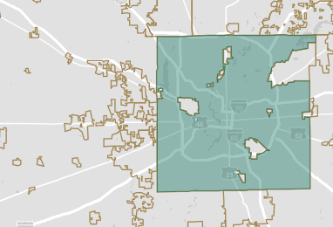

POPULATION
857,637

POPULATION
857,637

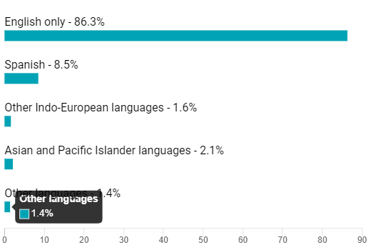

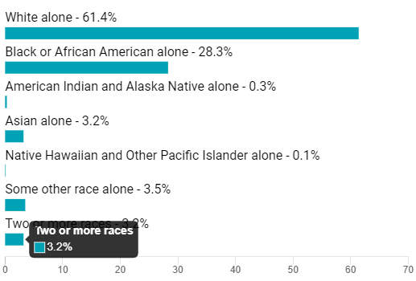

1-Year Estimates Table B below provides language spoken at home by ability to speak English for the population aged 5 years and over:

Table B
LANGUAGE SPOKEN AT HOME | Estimate | Margin of Error | Percentage | % margin of error
Population 5 years and over | 794725 | 708 | 794725 | (X)
English only | 685923 | 2711 | 86.3 | 0.3
Language other than English | 108802 | 2597 | 13.7 | 0.3
Speak English less than "very well" | 49914 | 1874 | 6.3 | 0.2
Spanish | 67538 | 1841 | 8.5 | 0.2
Speak English less than "very well" | 31531 | 1498 | 4 | 0.2
Other Indo-European languages | 12747 | 1200 | 1.6 | 0.2
Speak English less than "very well" | 3986 | 659 | 0.5 | 0.1
Asian and Pacific Islander languages | 17007 | 1113 | 2.1 | 0.1
Speak English less than "very well" | 10241 | 991 | 1.3 | 0.1
Other languages | 11510 | 1518 | 1.4 | 0.2
Speak English less than "very well" | 4156 | 731 | 0.5 | 0.1

Factor No. 2. The frequency with which LEP individuals come into contact with the service. CIRTA has not formally tracked the number of interactions between its programs and LEP individuals. CIRTA’s will establish as an option during registrations in programs offered to identify the number of Spanish-speaking LEP individuals.
Factor No. 3: The nature and importance of service provided by CIRTA. CIRTA provides reverse commute public transportation, rideshare and transportation-related information and referral services. Through the provision of these programs, CIRTA transports people to jobs in three suburban communities coming from within Indianapolis though work force connect programs. CIRTA assists people in forming carpools and vanpools, funds vouchers for emergency rides home from work to people who rideshare and provides information about and referrals to other transportation programs and services in Central Indiana.
Factor No. 4. The resources available to CIRTA to assure meaningful access to programs and services by LEP persons. CIRTA continues to dedicate funding to the translation of web-based and printed materials, and the hiring or contracting of one or more translators, in order to assure access by LEP persons.
CIRTA’s 2021 budget is largely made up of federal grants that support the provision of reverse commute transportation, rideshare services, and a web-based directory of transportation options. Due to the size of the organization and limited resources, CIRTA continues to focus its language assistance efforts on extending access for persons speaking Spanish. CIRTA’s rideshare program has translated a primary brochure into Spanish, has translated a form letter to rideshare participants into Spanish, and has employed one or more Spanish speakers who communicated verbally with Spanish-speaking LEP persons. Presently, one CIRTA employees is bilingual in English and Spanish.
Additionally, the CRITA website also includes a google translator allowing multi use language conversion in efforts to improve communication opportunities within our passengers and communities.

- CIRTA’s Public Participation Program
Recipients and sub-recipients of federal funding shall seek out and consider the viewpoints of minority and low-income populations in the course of conducting public outreach. CIRTA will take into consideration the perspectives of the minority and low-income population when planning significant changes in the operation of programs and services. The 2018 American Community Survey 1-Year Estimates report that the income in the past 12 months of 19.1% of Indianapolis-Balance metropolitan area residents aged 18 and over was below the poverty level. Concerning race and ethnicity, the American Community Survey 1-Year Estimates report that 10.7% of Indianapolis-Balance metropolitan area residents were Hispanic, Latino, or other and 28.3% were Black or African American. When planning future significant changes to programs and services, CIRTA will continue to take measures to include the viewpoints of minority and low-income people that may include:
- Surveying of low-income and minority users of CIRTA services through telephone interviews, in-person meetings or onboard surveys
- Holding well-advertised public input meetings in venues that are easily accessible to low-income and minority populations
- Holding of bi-monthly board meetings where the public is invited to attend
- Coordinating with organizations serving potentially affected low-income and minority individuals

VII Subcontractors and Vendors
All subcontractors or Vendors who receive payments form CIRTA where funding originates from federal assistance are subject to the provisions of Title VI of the Civil Rights Act of 1964 as amended.
Written contracts shall contain non-discrimination language, either directly or through specific bid package which becomes an associated component of the contract.

VIII forms

Employee Annual Education Form Title VI Policy
No person shall, on the grounds of race, color, or national origin, be excluded from participation in, be denied the benefits of, or be subjected to discrimination under any program or activity receiving federal financial assistance.
All employees of the Central Indiana Regional Transportation Authority (CIRTA) are expected to consider, respect, and observe this policy in their daily work and duties. If a citizen approaches you with a question or complaint, direct him or her to Title VI Coordinator. In all dealings with citizens, use courtesy titles (i.e. Mr., Mrs., Ms., or Miss) to address them.
FORM 2020 / Employee Acknowledgement of Receipt of Title VI Program
I hereby acknowledge the receipt of the Central Indiana Regional Transportation Authority (CIRTA’s) Title VI Program. I have read the Program and am committed to ensuring that no person is excluded from participation in or denied the benefits of its transit services on the basis of race, color, or national origin, as protected by Title VI in Federal Transit Administration (FTA) Circular 4702.1B.

Your signature _________________________________

Print your name _________________________________

Date___________________

