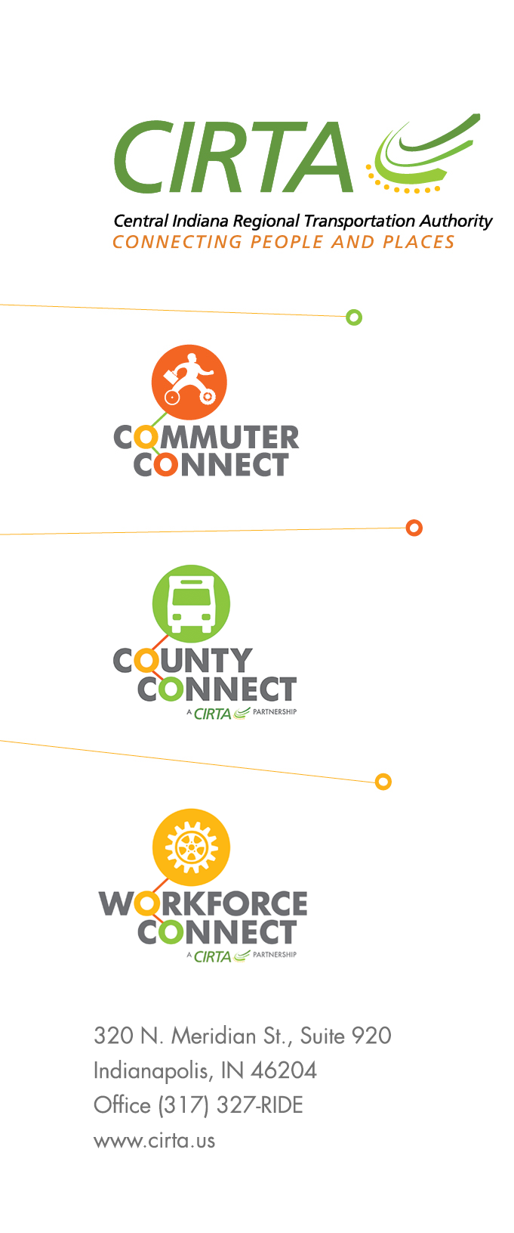
2023 CIRTA Board Meeting Dates

February 14, 2023

April 11, 2023

June 13, 2023

August 15, 2023

October 10, 2023

December 12, 2023

