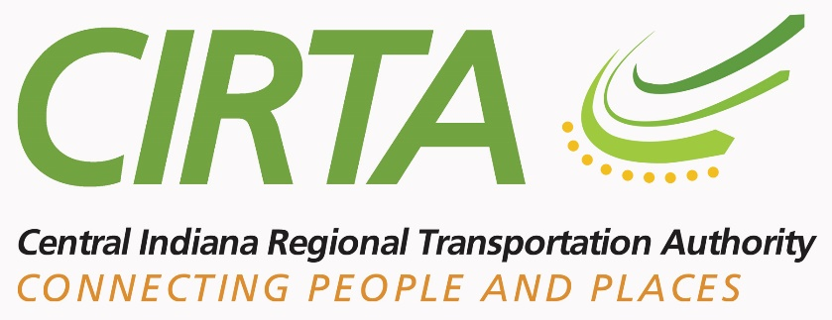
NOTICE UNDER THE AMERICANS WITH DISABILITIES ACT
In accordance with the requirements of title II of the Americans with Disabilities Act of 1990 ("ADA"), the Central Indiana Regional Transportation Authority (“CIRTA”) will not discriminate against qualified individuals with disabilities on the basis of disability in its services, programs, or activities.
Employment: CIRTA does not discriminate on the basis of disability in its hiring or employment practices and complies with all regulations promulgated by the U.S. Equal Employment Opportunity Commission under title I of the ADA.
Effective Communication: CIRTA will generally, upon request, provide appropriate aids and services leading to effective communication for qualified persons with disabilities so they can participate equally in CIRTA’s programs, services, and activities, including qualified sign language interpreters, documents in Braille, and other ways of making information and communications accessible to people who have speech, hearing, or vision impairments.
Modifications to Policies and Procedures: CIRTA will make all reasonable modifications to policies and programs to ensure that people with disabilities have an equal opportunity to enjoy all of its programs, services, and activities. For example, individuals with service animals are permitted on CIRTA public transportation vehicles.
Anyone who requires an auxiliary aid or service for effective communication, or a modification of policies or procedures to participate in a program, service, or activity of CIRTA, should contact David Krieg, Mobility Manager, at (317) 327-7433 or dkrieg@cirta.us as soon as possible but no later than 48 hours before the scheduled event.
The ADA does not require the CIRTA to take any action that would fundamentally alter the nature of its programs or services or impose an undue financial or administrative burden.
Complaints that a program, service, or activity of CIRTA is not accessible to persons with disabilities should be directed to David Krieg, Mobility Manager, at (317) 327-7433 or dkrieg@cirta.us.
CIRTA will not place a surcharge on a particular individual with a disability or any group of individuals with disabilities to cover the cost of providing auxiliary aids/services or reasonable modifications of policy.

