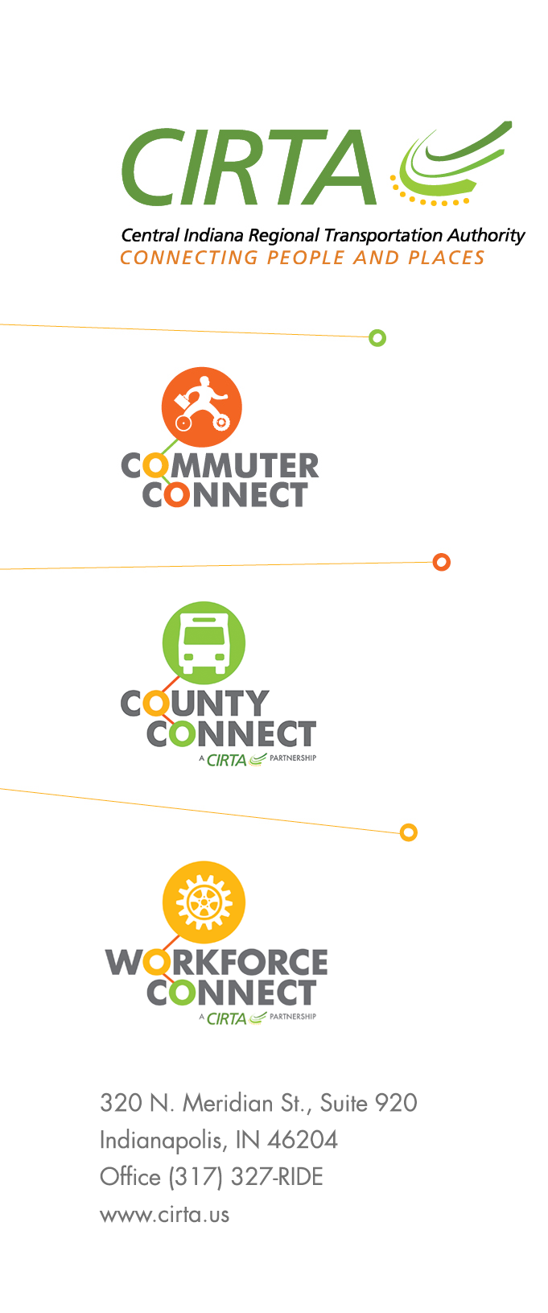
CIRTA Regional Administrative Capacity and Coordinated Technology Initiative
RFP #2021-1

Vendor Questions and Responses

Transit Innovator, LTRT – Transit Innovator Questions 02/10/2021 @1:46pm

1. The 2021 CIRTA budget indicates a line item with a budget of $64,600 for "CONSULTING - Finance Services, SVK and MIP". The scope for this assignment is more substantial in nature. Are you able to confirm the budget set aside for this project?
2. What is the timeline of this project and the deliverables?
3. Referring to Section 1 - Regional administrative and capacity initiative, first bullet under desired outcomes:
Does the assessment of regional capacity for opportunities to integrate operational and administrative functions include both fixed route and door to door services?
4. Can you please confirm if an electronic submission of the proposal to DeAndre Rhodes Sr. at drhodes@cirta.us. is sufficient, or if a hardcopy is also required?
5. This looks like it is more focused on the management side vs the tech side. We focus more on providing the tools to add updated fare collection - is this something that CIRTA is looking for as well? Is there another RFP out for tech?

Transit Innovator, LTRT – Transit Innovator Questions 02/24/2021 @ 9:01am

1. Can you confirm your desired completion date of November 2021 relates to Part 1 of the scope in the RFP? Part 2 of the RFP includes, in addition to analysis and planning, procurement, evaluation and negotiation with a vendor. This would be quite challenging to have done before November. What is the desired completion date for Part 2?
2. Can you confirm that the cover letter and staff resume will not be included in the 12-page count?

Transit Innovator, LTRT – CIRTA Question Response 02/17/2021 @6:02pm

- This RFP has a separate dedicated budget that is funded through a grant.
- As we are awarding in April, we do have some flexibility in the timeline but would like to see completion no later than November of 2021.
- This will encompass the providers within the county’s in our region, most of which are providing deviated fixed route, paratransit, and some medical transportation services.
- An electronic copy will be sufficient.
- The Regional technology, reservation and dispatch initiative is the 2nd part of the RFP that will focus on the technology and fare collections.

Transit Innovator, LTRT – CIRTA Question Response 02/24/2021 @11:05pm

- We understand additional time would be needed for establishing criteria after the analysis has been completed. With this said we are open to timeline options for the procurement planning, evaluations, and other related actions. Our goal would be to finalize procurement language no later than June of 2022.
- You may exceed the 12-page count for your cover letter and staff resumes.

