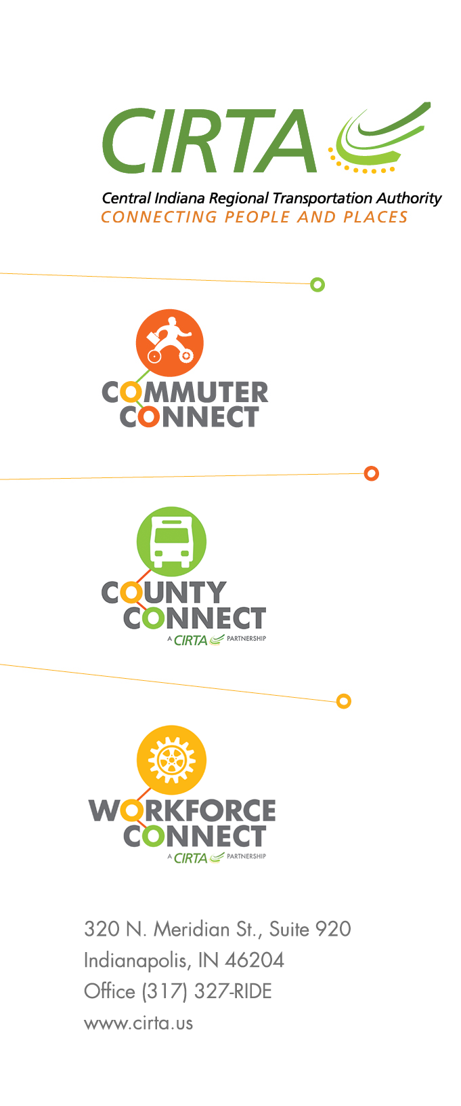

Central Indian Regional Transportation Authority (CIRTA) request for quote for Financial Management services

RFQ C 3-17-2021

Quotes due on April 7th 2021 at 10:00am Eastern time
Quotes should be sent electronically to jseber@cirta.us
Final quote evaluation and contract award date is April 13th 2021

SCOPE OF SERVICES

Onboarding and Initial Accounting Support:

The Contracted Financial team will work with the staff at Central Indiana Regional Transportation Authority (CIRTA) to develop processes and procedures for ongoing accounting processes, such as accounts receivable, accounts payable, payroll, bank reconciliations, and general accounting. The initial support will also include an assessment of the setup and configuration of CIRTA’s preferred accounting system, Quick books.

Weekly Accounting Support:

To maintain a strong financial foundation, certain accounting service tasks should be completed on a weekly basis. The financial contractor will perform the following tasks weekly, at the CIRTA offices as required:

Generate member/partner invoices as required, input member/partner payments in Quick Books.
- Process grant drawdowns and allocation as appropriate.
- Update Grant tracking form
- Provide system updates through FTA systems, NTD programs, SPOA Gateway and other applicable systems
- Manage the process to approve and pay vendor bills on a timely basis.
- Manage the payroll process in partnership with Managepoint.
- Other accounting activity as needed, including general journal entries and account reconciliations.

Monthly Financial Support:
Other tasks should be performed on a monthly basis. The financial contractor will perform the following tasks monthly:
- Develop and manage the monthly accounting close process.
- Review monthly bank account reconciliations.
- Prepare month checks for board approval and signature
- Reconcile other balance sheet accounts as necessary.
- Prepare financial statements and analyze for accuracy.
- Prepare a monthly financial reporting package and present to the Exec Director and Board as necessary.
- Prepare annual budget.
- Prepare for and oversee annual audits as well as other required audits.
- Prepare monthly, quarterly and annual financial reports as required for state and federal grants.
- Interact with the Exec Director and Board members to provide leadership and counsel on financial matters.
- Develop and manage a process for consistent cash flow analysis.
- Provide other financial analysis as needed.
- Provide other CFO related services as needed.
- Attend monthly meetings of the CIRTA Board and/or Joint Finance/Executive Committee.

The details above serve as a base overview of the general requirements and is subject to other applicable actions.

Contract terms will be 2 years with 3 one year extension options.
Pricing should be broke out for annual costs per year.
There is no page limit on quote submission. Again the quote should be submitted electronically. For any questions please contact John Seber at jseber@cirta.us and reference RFQ C 3-17- 2021

(

