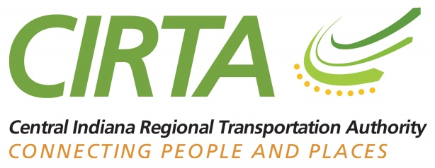

Central Indiana Regional Transportation Authority (CIRTA)
February 4, 2020 9:00 AM – 11:00 AM
MIBOR REALTOR® ASSOCIATION
1912 N. Meridian Street
Indianapolis, IN 46202
Board Members Present:

Don Adams
Christine Altman
Jerry Bridges
Andy Cook
Bill Ehret
Greg Henneke
Mata Moody
Mark Richards
Linda Sanders
Robert Waggoner
Dan Woo

Board Members Absent:
Tim Haak
Larry Hesson
Andrew Klineman
Cam Starnes

CIRTA Staff Present:
Lisa Bailey
Ehren Bingaman (Transpro Consulting)
Jennifer Gebhard
Desiree Sanks
Renee Walker
Heather White

The meeting was called to order by B. Ehret at 9:06 AM with a quorum.

Introductions
Introductions were made by the Board members, CIRTA/Commuter Connect staff and the public.

Consideration of Resolution #2020-02-01 – Adoption of consent agenda
Consent Agenda Items presented for consideration:
Consideration Memorandum of Regular Board Meeting of December 10, 2019
AP Voucher Register
Financial Report
Grants Docket

J. Bridges made a motion to accept the consent agenda items. G. Henneke seconded. The motion was approved by all in attendance.

Resolution #2020-02-02 – Resolution confirming 2020 Election of Officers
- C. Altman made a motion to approve electing of officers.
- A. Cook seconded. The motion was approved by all in attendance.

Resolution #2020-02-03 – Resolution Authorizing 2020 Signatories for Banking Purposes
- C. Altman made a motion authorizing2020 Signatories for banking.
- L. Sanders seconded. The motion was approved by all in attendance.

Resolution #2020-02-04 – Resolution of Approve Sponsorship Agreement with the Indianapolis Indians
- A. Cook made a motion of Sponsorship Agreement with the Indianapolis Indians.
- C. Altman seconded. The motion was approved by all in attendance.

Resolution #2020-02-05 – Resolution to approve contract signing with Transpro for Mobility Management Staff and Support
- C. Altman made a motion to approve contract signing with Transpro for Mobility Management Staff and Support.
- M. Richards seconded. The motion was approved by all in attendance.

Resolution #2020-02-06 – Resolution to appoint voting member to Indianapolis Regional Transportation Council (IRTC) Technical and Policy Boards
- J. Bridges made a motion to appoint voting member to IRTC Technical and Policy Boards
- L. Sanders seconded. The motion was approved by all in attendance. Jen Gebhard was voted as the voting member for Technical, Lisa will be the proxy. Christine Altman was voted as the voting member for Policy.

Resolution #2020-02-07- Resolution for board- appointed Staff Member to approve overhead expenses

- C. Altman made a motion to approve a board – appointed Staff Member to approve overhead expenses
- L. Sanders seconded. The motion was approved by all in attendance.

Resolution #2020-02-08- Resolution to extend contract with Transpro for interim executive management
- L. Sanders made a motion to approve contract extension with Transpro for interim executive management
- D. Adams seconded. The motion was approved by all in attendance.

Resolution #2020-02-09-Resolution Supporting the Governors Initiative Contained in House Bill 1070
- A. Cook made a motion to approve supporting the Governors Initiative Contained in House Bill 1070
- C. Altman seconded. The motion was approved by all in attendance.

CIRTA Updates
J. Gebhard stated that Commuter Connect made a record quarter for the last quarter, with a total of 651 new commuters, 25 new carpools, also 4 new vanpools. J. Gebhard stated that CIRTA will be creating new marketing tools and redesigning of the website.

E. Bingaman stated that he will provide more recommendations for CIRTAS strategic plan at the March board meeting.

R. Cockrum stated that any bill that is not out tonight will die- Senate 350. R. Cockrum would like to expand the transit. He also feels as if the transit system is falling behind. He suggests that the MPO works with the Chamber.

J. Thomas stated that she will be working on a “We Love Our Commuters” campaign. That is due to roll out the week of Valentine’s Day. She will be working with the Indianapolis Indians to tweak some of the sponsorship agreement.

Adjournment
The motion to adjourned was entertained and approved by all in attendance at 10:17am.

