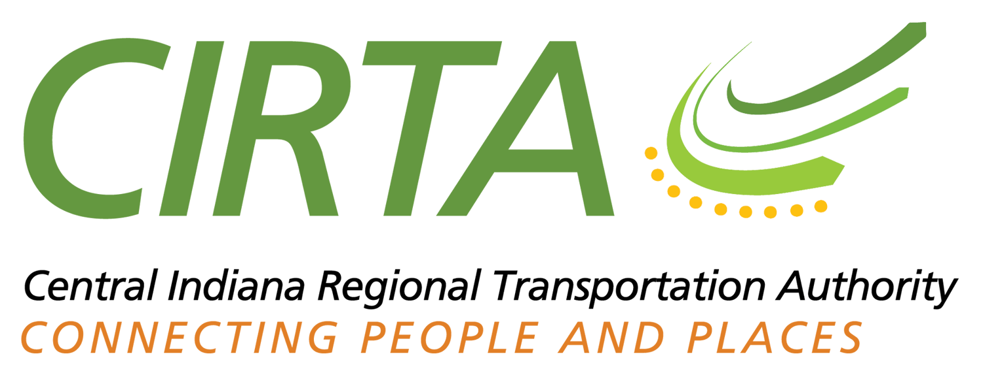

2017 Strategic Plan

Central Indiana Regional Transportation

Authority (CIRTA)

Prepared by CIRTA Board Members and Staff

Organizational Study by Cambridge Systematics, Inc.

Approved May 23, 2017

(This page intentionally left blank)

2017 Strategic Plan: Central Indiana Regional Transportation Authority (CIRTA)

Table of Contents
Summary 2
Introduction 2
Narrative 3
Organizational Purpose and Outlook 3
Vision 3
Mission Statement 4
Opportunities and Challenges 5
Assets 5
CIRTA organizational strategy 6
Emergent Strategy (“opportunity-oriented”) 6
Deliberative Strategy (“goal-oriented”) 8
Hybrid Strategy (or, “meeting in the middle”) 8
Detailed Activity Plan 9
Commuter Connect 9
Short-term and Ongoing 9
Medium- and Long-term 10
Workforce Connect 10
Short-term and Ongoing 10
Medium- and Long-term 10
County Connect 11
Short-term and Ongoing 11
Medium- and Long-Term 11
Planning 11
Short-term and Ongoing 11
Long-term 11
Advocacy 12
Short-term and Ongoing 12
Medium-Term 12
Operations 12
Medium-Term 12
Long-Term 12
Administration and Organizational Structure 12
Short-term and Ongoing 13
Medium-term 14
Long-term 15

Summary
CIRTA was created in 2004 to support regional public transportation of all types, whether as an operator, a program manager, or a coordinator. The organization has had a prominent role in promoting and implementing regional high-capacity transit initiatives like Indy Connect and local tax referenda, while simultaneously operating connective services in areas with immediate and conspicuous gaps, as well as administering Commuter Connect, Central Indiana’s travel demand management program. CIRTA intends to continue growing the success of these activities, while expanding a “brokerage” role that allows for better flow of resources for transportation services crossing funding districts. In the long-term, CIRTA envisions a regional consolidation of transit planning and operations across its entire service area.

Introduction
CIRTA is a regional transportation services agency, whose activities overlap, support, and complement those of other transportation entities in the Central Indiana region. Created in 2004, the agency aims to realize economies of scale in public transportation in the Central Indiana economic-metropolitan region, services which have historically been confined by local political boundaries. Overseeing the agency’s activities is a Board appointed by its member municipalities and counties. The centerpiece of CIRTA’s legislative efforts – the establishment of a regional transit tax to fund a truly regional transit system – has met with mixed success; while the state legislature approved a funding mechanism, the fragmented basis (by townships and counties) for adopting and administering the tax differs significantly from its original intended form. CIRTA continues to have a leadership role in implementation of the region’s transit plan (“Indy Connect”), and has assumed management of the regional travel demand management program (“Commuter Connect”). These activities were followed by the establishment of a regional mobility management program (“County Connect”) and a cross-county reverse-commute circulator program (“Workforce Connect”).

CIRTA’s historical activities reflect the employment of a two-pronged strategy, balancing short-term “emergent” activities aimed at filling existing gaps in regional transportation services with long-term “deliberative” ones that intend to restructure the administration of transit in Central Indiana. A third “hybrid” strategy bridging the other two has recently emerged, which attends to the application of short-term strategies to create new long-term opportunities. This Strategic Plan update proposes to maintain these emphasis areas, as follows:

- Emergent. CIRTA will maintain, as well as judiciously cultivate, expansion opportunities for its three core programs – Commuter Connect, County Connect, and Workforce Connect. Opportunities for expanding the service areas for these programs will be studied and, as appropriate, implemented. Recent successes with implementation of an Economic Improvement District (EID) can serve as an implementation model for the establishment of targeted services in transportation management areas (TMAs), such as vanpools and workforce connectors.

- Deliberative. CIRTA will continue to support the implementation of Indy Connect and the required passages of local taxes to advance its development. The fragmentation of transit taxing authority creates significant uncertainty with the timing of regional transit investments, as well as sets the stage for possible lack of coordination from taxing district to taxing district. More than ever, CIRTA must define and occupy the “broker” role that it has always been intended to fill.

- Hybrid. This category anticipates new opportunities arising out of emergent activities to realize deliberative goals. For example, the proposal (outlined below) of offering software to all County Connect stakeholders for scheduling on-demand service (an emergent strategy) could, following its initial implementation, be expanded to centralize scheduling for cross-county (and cross-service area) trips (a hybrid strategy), and eventually lead to centralized scheduling of all on-demand trips within the region (a deliberative strategy). In this way, hybrid strategies identify specific steps that bridge emergent and deliberative courses of action.

Narrative
CIRTA’s last Strategic Plan was completed in 2006; it proposed legislative establishment of a regional transit funding source, as well as subsequent restructuring and project implementation activities. While the efforts of CIRTA and its partners eventually yielded a transit funding solution that the Indiana General Assembly passed in 2014, the fragmented nature of this source of transit funding (which is enacted at the township or county level) poses strong challenges to the implementation of regional transit as originally conceived.

In order to address the issues raised by the legislative funding mechanisms, as well as set new aspirational targets, CIRTA began the process of updating its Strategic Plan in early 2016. The process was divided into two phases: first, an initial period of reviewing mission and existing needs and activities (which concluded in May 2016), and a subsequent period of reviewing proposed strategies, activities, organizational structures, and timeframes (which concluded in March 2017).

By definition, projections and foresight are more difficult as uncertainties in the external environment increase; organizational strategy at such times needs to respond by adapting proximate objectives, whatever other long-term goals may be retained. Focusing on achievable goals helps the organization avoid the twin hazards of paralysis and inflexibility. Without sacrificing a long-term outlook for regional transit implementation, the current Strategic Plan update nevertheless aims to foster short-term successes.

The current Strategic Plan builds upon, rather than supplants, prior planning initiatives (including the 2006 Strategic Plan and 2010 Organizational Study). In addition to reconsidering CIRTA’s long-term organizational outlook in light of legislative changes to transit funding options, the Plan considers short-term steps that provide improvements in regional transportation services while also advancing towards CIRTA’s long-term goals.

Organizational Purpose and Outlook

Vision
CIRTA’s regional transit vision, as shared by its fellow stakeholders (discussed more below), is largely elaborated by two separate, but related, planning initiatives – the Indy Connect Plan and the Coordinated Public Transit Human Services Transportation Plan (aka the “Coordinated Plan”). Indy Connect, the first plan, focuses on a proposed high-capacity transit (HCT) system, initially anchored by Bus Rapid Transit (BRT) facilities and perhaps later transitioning to light-rail transit (LRT). These facilities serve as the basis for a re-orientation and expansion of community fixed bus routes feeding into the HCT system. The Coordinated Plan, by contrast, focuses on the on-demand transit component that human services agencies frequently rely upon (due to their clients’ difficulties in using fixed-route transit), and which in rural areas frequently constitutes the only type of transit service available.

These sources jointly envision a Central Indiana region that has a higher reliance on transit than it currently has, with public transportation services being faster, more accessible, and more reliable than is currently the case. Accomplishing this vision will entail an increasing degree of coordination and centralization of transit planning, scheduling, and operational activities, potentially necessitating the consolidation of multiple agencies. The final transit network will be an integrated system of different technologies, anchored by a core network of HCT facilities enabling greater overall system speed and efficiencies, and supplemented by local route improvements and improved on-demand transit will enable more access to the region. Flexible services, which can combine efficiency with local access in some circumstances, will expand beyond their current reach in Johnson and Shelby Counties and be increasingly available in other suburban areas.

Mission Statement
CIRTA’s mission statement is as follows:

“It is CIRTA’s mission to become the thought and implementation leader for regional transit and travel demand solutions in Central Indiana, and to serve as a model institution for other regions in Indiana and the U.S., as we help create healthy communities through public transportation.”

As the only public transportation organization with regional scope and representation, CIRTA is uniquely situated to help transit agencies collectively manage the regional public transportation system. The mission statement is deliberately crafted to allow CIRTA to assume a variety of roles in order to achieve its organizational vision, potentially including the following:

- Coordinator/ Facilitator: Matching up supply with demand, as well as spreading the awareness of new transportation modes
- Broker: Assembling funding sources for the provision of transportation, and potentially managing procurement, disbursement, and reporting requirements associated with those sources.
- Educator/Advocate: Disseminating information and promoting transportation options to Central Indiana residents and employers, as well as on the benefits of alternative transportation investments.
- Provider: Active supplier of transportation services (such as turnkey contracts), including planning, scheduling, procurement, management, disbursement, and reporting.
- Organizer/Initiator/Catalyst: Developing customized transportation solutions for specific geographic and/or trip purpose transportation markets.

Opportunities and Challenges
Many components of the public transportation system are currently being implemented, and preparations for fulfilling other components to the network are being made. Issues that have yet to move towards a resolution, and which provide both an opportunity for action and a need for redress, include the following:

- Inter-regional transit. While inter-regional transportation is primarily the purview of INDOT, it should be noted that there are several areas within Central Indiana that, owing to their location on the periphery of the region (as commonly defined), have workforce markets that overlap other regions, notably Boone County (with Lafayette), Hamilton County (with Kokomo), Morgan County (with Bloomington), and Johnson/Shelby Counties (with Columbus). There may be “win-win” opportunities for collaboration with these other regions. Vanpools are also a significant asset for inter-regional access that should not be overlooked.
- Inter-city transit. The Indy Connect initiative, of which CIRTA is a part, has been rightly lauded for its achievements. Nevertheless, there are unaddressed connectivity issues; for example, Anderson and Muncie do not have any planned HCT connections. The “ring” counties around Indianapolis might benefit from fixed circumferential connections between county seats. Park and ride lots (PNR) may not only benefit transit systems, but carpoolers and vanpoolers as well.
- Intra-county transit. IndyGo has reoriented its local route system to benefit from the efficiencies of the Red Line and to meet other local objectives (enabled by the recent passage of the countywide transit tax), and Hamilton County has done some local route planning. Flexible transit has considerable potential for improving levels of service and efficiency outside of Marion County, but has to-date been applied in only two jurisdictions (Shelbyville and northern Johnson County).
- Circulation. Large Indianapolis employment districts, such as Downtown Indianapolis and Park 100, rely on fixed route bus to double as circulation systems. District-based circulator shuttles may be a substantial improvement, and allow resources for core bus service to be used more efficiently. Local ridehailing services have potential for providing “last-mile” services to and from transit routes.

Assets
CIRTA’s region is defined by its membership – those Counties in Central Indiana that have opted to join (Boone, Delaware, Hamilton, Hancock, Hendricks, Johnson, Madison, Marion, Morgan, and Shelby Counties). Other organizations with responsibilities for transportation services exist in the same area, and while duplication of services should be avoided, these partners are assets in the implementation of CIRTA’s organizational vision, including the following:

- Local public transit agencies. This category includes the Indianapolis Public Transportation Corporation (aka “IndyGo”), City of Anderson Transit System, Muncie Transit System, and countywide flexible and on-demand service providers within CIRTA’s jurisdiction.
- Human service agencies. Mobility constitutes a core concern of many social service agencies within the region; some organizations provide their own specialized transportation for clients, while others work with more traditional transit agencies to increase mobility.
- Metropolitan Planning Organizations (MPOs) are regional planning and coordinative entities whose activities are required to receive federal transportation funds. They are determined primarily by data from the U.S. Census, although there is some discretion to expand boundaries. Currently, CIRTA encompasses three (3) MPOs – Anderson, Indianapolis, and Muncie – and abuts a fourth to the south, the Columbus MPO.
- Central Indiana Regional Development Authority (RDA). This form of government oversees regional economic development initiatives in partnership with the Indy Chamber. The potential for the RDA to serve as a funding conduit for transit projects exists.

CIRTA organizational strategy
Organizational strategy can be separated into “deliberative” and “emergent” forms, with the key distinction being specificity; deliberative strategy targets clear outcomes with specific means for achievement, while emergent strategy denotes flexibility with regards to these items, coupled with a greater emphasis on short-term opportunities. Both forms have their advantages, with deliberative strategy having the advantage of a clearly communicated purpose, and emergent strategy being flexible and adaptable to changing circumstances.

Historically, CIRTA has pursued both deliberative and emergent strategies. The deliberative component to CIRTA’s strategy (which might be called “ends-oriented”) has consisted of legislative activities to allow for regional transit funding, and support of the Indy Connect regional transit planning initiative. The emergent component (which might be called “opportunity-adaptive”) is comprised of low-cost, high-value activities that serve supplemental roles in regional transportation services; examples include the administration of the Commuter Connect program, and initiation of the County Connect and Workforce Connect programs. Recently, CIRTA has been more explicit in tying its emergent activities to deliberative outcomes (which we will call a “hybrid” deliberative-emergent approach); examples include securing status as a grantee under both the FTA and PMTF programs.

CIRTA will continue a three-fold (emergent, deliberative, and hybrid) approach to its organizational strategy. Areas of emphasis are outlined below; subsequent strategies will spell out actions in more detail as necessary.

Emergent Strategy (“opportunity-oriented”)
This branch of strategy consists of refinements to and judicious expansion of existing programs, and the associated identification and fulfillment of associated opportunities. The Coordinated Plan has a strong relationship to this strategy component; it emphasizes capacity building activities, centralization of key components that may realize economies of scale (e.g., software acquisition, scheduling, etc.), and information sharing. The Coordinated Plan also addresses several components of regional transit such as fare coordination and scheduling centralization, which, while they have been acknowledged by Indy Connect as important for eventual completion of HCT, do not as of yet have a working plan.

- Funded by the Federal Highway Administration’s (FHWA) Congestion Mitigation and Air Quality (CMAQ) program, the Commuter Connect Program will continue to look for ways to advance and expand travel demand management in Central Indiana. Such an expansion may mean cultivating supplemental or expanded funding bases, whether from CMAQ or some other source. The vanpool program will continue to be strongly supported for its role in inter-regional access.
In order to ease the ability of carpoolers and vanpoolers to coordinate, Commuter Connect will work with INDOT, the three MPOs, and local jurisdictions to jointly assess the feasibility for park-and-ride lots at strategic locations around CIRTA’s region.
- CIRTA is acting as the backbone organization for a collective impact mobility management initiative called County Connect, which regularly convenes the rural transportation providers in the service area. The objectives of this coordination are to harmonize the efforts of all the stakeholders, identify projects of mutual interest, and enhance advocacy issues. The initiative uses the Coordinated Plan as its base, but CIRTA staffs and manages the effort. This program will continue to support and coordinate the activities of regional transit service providers, as well as helping to identify the highest and best uses of scarce federal funding. The County Connect points that serve as meet-ups for abutting services will occasionally be reevaluated, and the prominence and facilities present at those points will be expanded as needed. Flexible transit (deviated route service) will increasingly be favored as a supplement to on-demand transit, with careful assessment of potential and actual cost savings.
New programs to improve data collection and fruitfully apply scheduling and tracking technology will be implemented as feasible. CIRTA will partner with local transit providers to promote and implement consistent service and fare policies across the region, with fare consolidation and a single-fare system being the ultimate goal; CIRTA’s leadership will require an expansion of its “brokerage” role.
Some advocacy will be required here, as local governments with funding constraints have started cutting back their contributions to transit, putting some systems at risk. Assistance from board members, with support from CIRTA staff, to leverage their networks when needed will go a long way to develop support for establishing, maintaining, and even expanding local service.
- The Workforce Connect circulator program will judiciously assess areas for possible expansion and work with local stakeholders to enact new services. CIRTA will continue to identify and disseminate best practices for securing permanent funding for Connectors and other district-based transportation services.
The visibility of the Connectors provides a good base for Commuter Connect employer outreach, and joint promotion of the two will take place whenever feasible. Vanpools will be jointly offered as a possible new service to potential districts. Public-private partnerships known as Transportation Management Areas (TMA) may be formed where feasible for guiding and funding transportation services to specific employment districts. The activities of these TMAs could be funded by a state public-private funding tool known as an Economic Improvement District (EID).

Deliberative Strategy (“goal-oriented”)
This branch of CIRTA’s overall strategy is aimed at correcting for major gaps in regional services and coordination, and for implementing corrections and/or improvements to state legislation. With discretionary transit funding now being fragmented among multiple taxing jurisdictions, CIRTA will take the necessary steps to assemble these sources into consolidated funding streams as appropriate to implement regional projects.

Centralization of transit planning, scheduling, and operations is a key long-term outcome of CIRTA’s deliberative strategy. Such centralization may eventually require consolidation across geographies and subject areas of multiple organizations, potentially including one or more of the metropolitan planning organizations (MPOs) and transit providers in CIRTA’s service area. Such consolidation may take place under CIRTA’s umbrella, the umbrella of another existing regional organization, or may result in the creation of a new, as-yet-undefined regional transit agency.

The Indy Connect Plan, strongly associated with the deliberative strategy, varies significantly by area. In Indianapolis-Marion County, which has an existing fixed-route bus transit system, the plan is very specific for future bus service routes and frequencies. For some of the areas immediately surrounding Marion County, which predominately have on-demand or flexible transportation services without fixed route systems, some local route planning has been done. It is noteworthy that the Cities of Anderson and Muncie, which have fixed-route bus systems, are not included in the Indy Connect Plan.

- Legislative activities. CIRTA will continue to work with pertinent stakeholders to identify and advance opportunities to improve transit funding. The current legislation allowing for transit tax referenda has areas that can be refined, including increasing the governmental entities that are eligible to place referenda on the ballot. Indiana’s Public Mass Transit Fund (PMTF) has been undergoing a decline in real dollar terms, and much legislative work has been done to reverse this trend. Another potential area for legislative activity is a clarification of the eligibility of tax increment finance (TIF) funds for providing transit. Legislative action to limit employer liability for carpooling and vanpooling could have a substantial impact on CIRTA’s Commuter Connect program.
- Membership. CIRTA will be open to discussion of admitting new member counties. In reviewing CIRTA’s statute, it is apparent that some revisions and refinements may be necessary to accommodate such a request, and may be desirable for clarifying existing membership requirements.
- Funding for transit. As fixed-route transit expands outward from Marion County, CIRTA will take on more of a leadership role in promoting funding referenda as permitted by Indiana law. CIRTA will also identify prospects and promote development for new and expanded transportation management areas (TMA), possibly funded by Economic Improvement Districts (EID).

Hybrid Strategy (or, “meeting in the middle”)
This strategy component can be viewed as activities with stand-alone value, but which simultaneously address issues with long-term implications for regional transportation services provision. Several strategies already discussed, such as park-and-ride lots and expansion of CIRTA’s “brokerage” role, serve as the base for implementing these “mid-range” strategies.
- Demonstrating increasing value in the administration of federal and state funding.
  - Demonstrate effectiveness and efficiency
  - Explore opportunities for administration and consolidation of regional funding mechanisms.
- Implementing concrete steps towards centralization of regional structures:
  - Data collection
  - Scheduling
  - Fare policy
  - One-stop shopping – brokerage role
    - Voucher program – opportunity to develop CIRTA’s brokerage role
- Economic Improvement Districts (EIDs) have shown potential in funding district-based transportation services. These districts may be more generically referred to as Transportation Management Associations (TMAs), and can serve as a bridge between local and regional transportation services coordination, with CIRTA conducting the following activities:
  - Identify areas with high employment density for potential implementation of TMA/EIDs (e.g., Hamilton County/US 31 corridor, Downtown Indy, etc.).
  - Stakeholder identification and cultivation
  - Help conduct business planning for individual TMAs and associated EIDs
    - Services
    - Funding
    - Staffing
  - Contract administration
  - Vendor management

Detailed Activity Plan
(Note: for purposes of this document, unless otherwise specified, “short-term” refers to 1-2 years after adoption of this Plan, “medium-term” refers to 2-3 years, and “long-term” to 3-5 years. These timeframes are speculative, and should not be interpreted as rigid requirements for implementation of the Plan.)

Commuter Connect
The Commuter Connect initiative is a mature program, with administrative decisions being made on an as-needed basis. Strategic initiatives for the program are listed below:

Short-term and Ongoing

- Examine the benefits and costs for expanding the program outside of its current service area, potentially including Delaware County, Columbus/Bartholomew County, Kokomo/Howard County, and Lafayette/West Lafayette/Tippecanoe County. Such expansions may help the long-term viability of the program by diversifying its funding base and providing alternative models for implementation, as well as leveraging economies of scale in its administration.
Due to the geographic specificity of the current funding source for the program, new areas would need to identify their own sources of funding for the program if they wished to participate, and staffing and administrative resources would need to be evaluated if expansion is deemed desirable. If this expansion occurs and is successful, long-term hosting of the program (either at CIRTA or with an as-yet unnamed third party) should be evaluated.
- Leverage employer networks developed as resources in the identification of opportunities for other programs (e.g., Workforce Connect).

Medium- and Long-term
- Formal park-and-ride lots will be studied as a strategy for increasing carpool and vanpool mode share. INDOT is a major stakeholder in such a strategy, owing to its large ownership and maintenance of public right-of-way. Such a study will include an evaluation of potential benefits, identification of potential sites and costs, and an implementation plan.

Workforce Connect
Employment in Central Indiana continues to decentralize, which can create hardships for low-income Indianapolis residents trying to access jobs in suburban industrial and commercial districts. Accordingly, workforce connectors, which transport IndyGo passengers to destinations over the Marion County line, have recently seen a surge in interest. Additionally, Economic Improvement Districts (EIDs), a mechanism for funding public-private partnerships, have come to be associated with the Workforce Connect program. Strategic actions for the Workforce Connect program are as follows:

Short-term and Ongoing
- Judiciously support new implementation of workforce connectors in areas where the following criteria have been met:
  - A commitment of local funding
  - Sufficient employment density (of jobs requiring no more than moderate skill levels) to merit consideration
  - Whenever possible, reasonable access of the proposed Connector to a primary fixed-route transit service (e.g., IndyGo, City of Anderson Transit System, etc.).
- Serve as technical resource for the implementation of EIDs for workforce commuter options, including Connectors, but also carpooling, vanpooling, and other services befitting a transportation management agency (e.g., parking).
- Use workforce connectors (both existing and proposed) as an opportunity to increase the visibility of the Commuter Connect program to employers, through the expansion of CIRTA’s employer contacts database and by using the Connectors as a media platform.

Medium- and Long-term
- Identify opportunities for bridging Connector services into higher-level suburban transit systems.

County Connect

Short-term and Ongoing
- Review the Coordinated Plan to identify activities and responsible parties for the coordination of transportation and human services in Central Indiana.

- Launch and review the My Freedoms Voucher Program. Data collected from the program will be used in program evaluation, as well as identifying additional opportunities for the provision of new services (either by CIRTA or by partnering agencies).
- Identify and procure centralized (i.e., CIRTA-administered) automated vehicle location (AVL) and scheduling software solutions that partner stakeholders may utilize.

Medium- and Long-Term
- Identify opportunities for centralization of reporting requirements associated with federal and state programs, including but not limited to FTA National Transit Data Base (NTD) and PMTF.
- Develop model service policies for County Connect agencies to consider adopting.
- Continue to implement and monitor outcomes from the regional Coordinated Plan.

Planning
Currently, planning is an ad hoc function carried out along programmatic lines. In the short-run, this arrangement is expected to continue, but eventually planning will be separately identified as a CIRTA service, at first as a separate line function, then subsumed under Administration to avoid organizational bloat (see section on Organizational Structure, below, specifically figures 2, 3, and 4).

Short-term and Ongoing
- Identify and assist in implementing opportunities for establishing focused transportation services (including, but not limited to workforce connectors and vanpools) in employment districts as transportation management areas, potentially funded by economic improvement districts (EIDs).
- Continue to support the study and identification of potential opportunities for inter-regional transit options, as well as transit to metropolitan areas outside of Central Indiana (e.g., Lafayette, Bloomington).

Long-term
- Leverage CIRTA’s expanding brokerage role into regional discussions of fare integration, first as components to cross-county payments for selected trips, and later as a consolidated payment system.

Advocacy

Short-term and Ongoing
- Support transit referenda in pertinent townships and counties within the Indy Connect service area as needs require.
- Support regional and local transit planning initiatives that are associated with the Indy Connect transit plan for Central Indiana.
- CIRTA will continue to seek changes and refinements to the transit tax legislation, as needed, such as expanding allowable units of government to hold referenda to include all municipalities, as well as to continue to seek a centralized funding mechanism, as originally intended. Fragmented financing structures resulting from decentralized financing through local referenda will invariably cause the need for more centralized funding through legislation.

Medium-Term
- Legislative fixes to limit employer liability for carpooling and vanpooling shall be reviewed and investigated during this phase.

Operations
Currently, service operations are organized along programmatic lines (i.e., Commuter Connect, County Connect, and Workforce Connect). As the number and quality of services increases, it is likely that management of operations, including vendor procurement, will become increasingly time-consuming and deserving of specialized attention.

Medium-Term
- Establish an operations section that assumes the responsibilities of vendor procurement and contractor oversight.

Long-Term
- Subsume the brokerage role under the operations section as it continues to develop.
- Depending on opportunities and interest on the part of partner stakeholders, CIRTA may assume a role as a central dispatcher and scheduler of services. Such a move is worthy of separate study, as it is not clear as of this writing what the financial and staffing implications of such a change would be.

Administration and Organizational Structure
As part of the strategic planning process, CIRTA contracted with Cambridge Systematics to produce an organizational study that compared and contrasted governance structures of other regional transit organizations in the U.S., with potential short-term and long-term applications to CIRTA. While the study is too long to incorporate fully in this document, its main recommendations for CIRTA’s organization are shown below; for comparison purposes, the existing organizational structure is shown below in Figure 1:
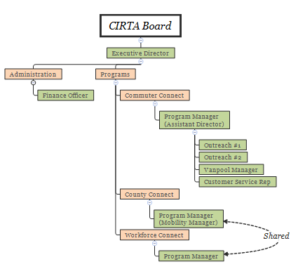
Figure 1: Existing Organizational Structure (green: staff roles; orange: function)

Short-term and Ongoing
- CIRTA’s organizational structure will prepare to accommodate additional functions, as outlined in Figure 2, below. Planning will be separated out into a separate organizational function, which will include local transit planning (including the development of economic improvement districts), data collection, and expanding the nascent “brokerage” role of the organization. The finance officer and the mobility manager positions will have overlap with the brokerage role.

- CIRTA will judiciously expand staffing resources when necessary, in accordance with the following principles:
  - Match Commuter Connect resources to program activity; if the service area or number of employers within the program expands, additional staff may be necessary to maintain levels of service.
  - Use EIDs to provide additional staffing capacity associated with greater program activity, as appropriate.
  - Cross-train staff to the extent feasible, so that core staff activities have multiple personnel knowledgeable of that function. Financial and bookkeeping should have top priority here.
  - Utilizing technology to maximize the productivity of existing staff will take preference over increasing staff size.
- An organizational issue that will be addressed in the near-term is the relationship and potential overlap between CIRTA, the Central Indiana Regional Development Authority, and the three metropolitan planning organizations (Anderson, Indianapolis, and Muncie) within CIRTA’s service area. Discussions will be initiated between these organizations during this phase to identify areas of mutual interest and mitigate areas of possible future duplication of effort. Ideally, a written statement partitioning regional transit activities will be developed and approved by the organizations’ respective governing bodies.
- Legislative adjustments to CIRTA’s enabling legislation will be explored to determine if revisions are required, for items such as expanding membership and governance issues which could arise as a result of expanded membership on the CIRTA board.

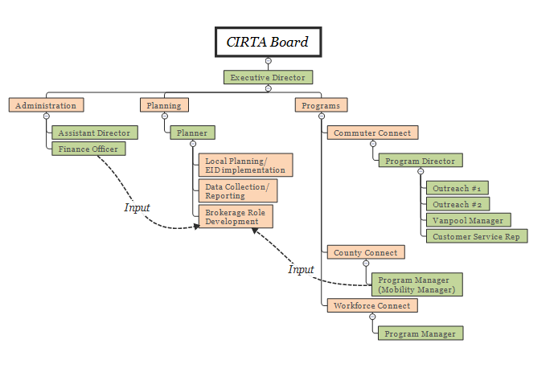
Figure 2: Near-term (possibly 1-2 years) Organizational Structure (green: staff roles; orange: function)

Medium-term
- CIRTA’s organizational structure will be further developed as per Figure 3 (below). The organizational focus in this stage will be to develop an operations branch, which will assume control of contracting, procurement, and vendor management from other staff. Additional staff may be needed to develop the brokerage function that has previously been discussed, the scope of which is expected to expand in this stage. Depending on the degree to which management of capital projects will fall under CIRTA’s purview, additional staffing may be required for implementing these projects. As staff size expands, additional administrative functions (namely an office manager) may be required to oversee human resources, IT, and supply functions.
- The Red Line is expected to begin operations during this phase, and expectations for expanding high-capacity transit (HCT) services into surrounding counties is expected to build. CIRTA’s brokerage role will take on increasing importance as HCT projects continue to come on-line. Discussions regarding the oversight and operations of a regional transit system will take place, and appropriate preparations made in CIRTA’s organizational structure.
- The expansion of the brokerage role will undoubtedly entail an increase in accounts receivable. Working capital needs will be closely monitored; if necessary, a line of credit with sufficient ability to cover several months’ worth of expenses will be procured.
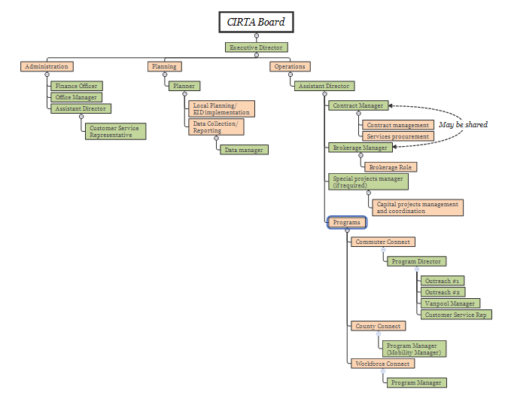
Figure 3: Medium-term (possibly 2-3 years) Organizational Structure (green: staff roles; orange: function)

Long-term
- CIRTA’s organizational structure will continue to evolve along the lines shown in Figure 4 (below). In this phase, organizational functions will consolidate along administrative, planning, and operational lines, each of which will have a director-level position. The operations branch will continue to expand with the addition of centralized scheduling and dispatching functions and staff.
- Opportunities for centralization and consolidation of transit agency functions (including planning, scheduling, and operations) will continue to be explored.

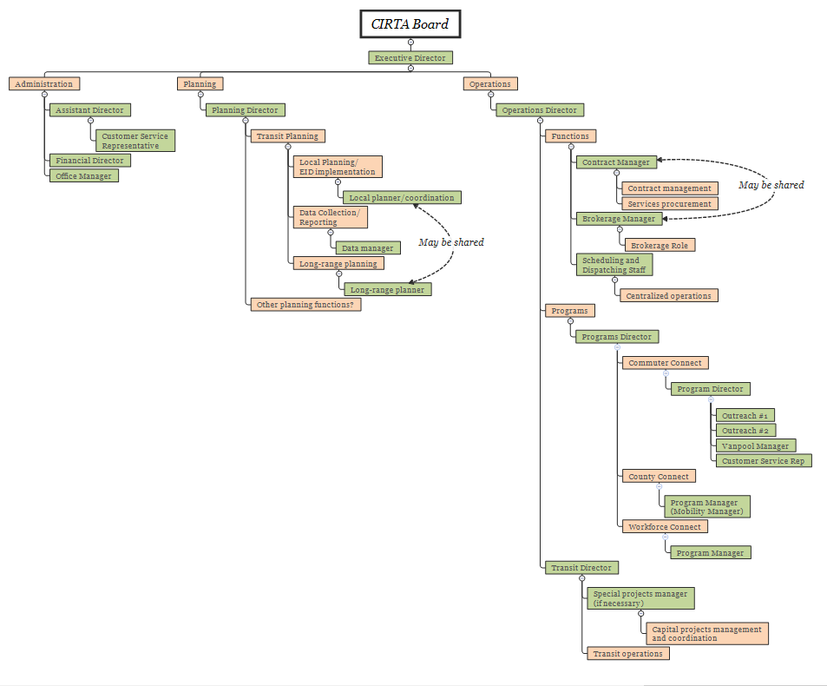
Figure 4: Long-term (possibly 3-5 years) Organizational Structure (green: staff roles; orange: function)
The prior (2010) Organizational Study exclusively focused on CIRTA’s long-term organizational structure, In particular, the study recommended a continued growth in the working relationship between CIRTA and the Indianapolis MPO, including (but not necessitating) consolidation of the two, possibly into an altogether different organization. This recommendation still remains relevant, although the incongruity between CIRTA’s and the MPO’s respective service areas merits additional consideration.

The prior study unabashedly proposed that CIRTA and IndyGo explore consolidating into a single, geographically integrated regional transit operations entity; however, this finding and its associated recommendations (such as the dissolution of IndyGo’s property tax) clearly depended on the enactment of a unified regional transit tax, something that is not possible under the tax legislation that was subsequently approved. Accordingly, CIRTA’s development and application of its “brokerage” function is a prerequisite for any discussions of operational consolidation. With it being possible for multiple counties and townships to have separately administered transit tax districts and revenue streams, CIRTA must work diligently to ensure that the resulting taxing “patchwork” resembles a unified regional tax district to the greatest extent possible, prior to any serious discussions of operational consolidation.

Despite recommending consolidation of the urban systems (IndyGo and CIRTA), the prior study advocated that rural transit operators remain separate. Since then, perhaps in response to a rising demand for rural trips that cross different service areas, these rural operators have argued for a degree of centralization of certain functions, including data collection, grant reporting, and perhaps even scheduling. These findings suggest that CIRTA explore ways to assist its rural partners in these functions.

A plan for increased and expanded public transportation supply that encompasses most, but not all, of CIRTA’s service area. See www.indyconnect.org for more details.
The Coordinated Plan serves to ensure that mobility-disadvantaged populations (e.g., the elderly, the infirm) have adequate access to public transportation services. The Plan is a requirement for programming funds under the U.S. Federal Transit Administration’s (FTA) Section 5310 program.
Mintzberg and Waters (1985). “Of strategies, deliberate and emergent.” Strategic Management Journal 6(3). July/September 1985, pp 257–272.

