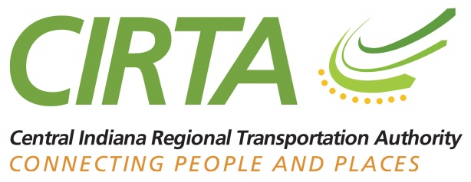

CIRTA 2017 Strategic Plan Overview

Over the past decade, the transit picture in Central Indiana has changed dramatically, and more changes are on the horizon. As the only regional transit entity in Central Indiana, CIRTA (the Central Indiana Regional Transportation Authority) is a leader in the evolution of the region’s public transportation services. Now CIRTA Is meeting the needs of the new transit landscape with a strategic vision that allows for regional planning, with the flexibility for local implementation.

Mission
It is CIRTA’s mission to become the thought and implementation leader for regional transit and travel demand solutions in Central Indiana, and to serve as a model institution for other regions in Indiana and the U.S., as we help create healthy communities through public transportation.

Background
When CIRTA was formed in 2004, transit in Central Indiana was sparse and disconnected. CIRTA coordinates transit planning and implementation for the region with other transit partners, such as local service providers and the MPOs (metropolitan planning organizations) in Indianapolis, Madison County and Delaware County. In that role, CIRTA has:
- helped develop and communicate the regional transit plan known as Indy Connect;
- been a leading partner on the state law for local tax referenda that created opportunities for dedicated transit funding;
- operated programs to address specific needs, including Commuter Connect (a ride-share program using cars and vans); County Connect (coordinating rural transit providers); and Workforce Connect (a cross-county reverse commute program);
- brought leadership and expertise to doughnut counties on options for mobility improvements that feed into a regional vision.

CIRTA is enthusiastic about improving the region’s mobility options. Approval of dedicated transit funding in Marion County was an important step for the entire region, and CIRTA is proud of its role in advancing the Marion County Transit Plan through education and outreach. However, it is just the first step. State legislation for tax referenda requires local implementation at the county or township level, which requires unique mobility solutions for each locality. CIRTA’s new strategic plan positions it to provide that local consulting role while moving the region forward in a smart, coordinated fashion.

Role
In developing the 2017 strategic plan, CIRTA defined its role as having five parts:
- Coordinator/Facilitator: Matching supply with demand and spreading awareness of new transportation modes and opportunities
- Broker: Assembling funding sources for transportation, and managing procurement, disbursement and reporting requirements affiliated with those sources
- Educator/Advocate: Spreading the word about transportation options and the benefits of alternative transportation
- Provider: Supplying transportation services
- Organizer/Initiator/Catalyst: Developing transportation solutions for specific needs and markets

As the only public transportation organization with regional scope and representation, CIRTA is uniquely situated to help transit agencies collectively manage the regional public transportation system. The new strategic plan allows CIRTA the flexibility to be responsive to the changing transit landscape, while delivering specific services to fill mobility gaps in the region.

Strategies
Following are the key components of the CIRTA strategic plan:
- Strengthen partnerships with other regional planning organizations such as the Indianapolis, Anderson and Muncie MPOs, as well as the Indiana Department of Transportation (INDOT) to provide smart transportation planning.
- Expand the Commuter Connect program, and potentially create park-and-ride lots throughout the region.
- Expand, enhance and improve the County Connect program, which brings together the transit providers in the counties around Marion, to enhance efficiencies.
- Expand the Workforce Connect program, which links workers in one county to jobs in another.
- Continue to improve transit funding, considering all possible funding mechanisms and opportunities, including public-private partnerships known a Transportation Management Areas that can be funded via Economic Improvement Districts.
- Provide expertise and consulting services to area townships and counties as they explore dedicated transit funding via referenda or other methods.
- Provide valuable centralized services for smaller transit providers such as data collection, scheduling and fare policies.
- Act as a catalyst to develop ways in which to leverage and grow funding to create a regional funding mechanism and to be prepared to administer those funds for the benefit of the whole region.

As one might suspect, over time, the pursuit of these strategies would require the growth and re-organization of CIRTA and its staff. That growth has been mapped out in a series of steps reaching well into the future; however, that growth will not be undertaken until the organization sees both the demand and funding opportunities for its expanded operations.

